St Catherine’s Community Services Centre

Strategic Plan 2024-2028


Table of Contents
Introduction from the Manager / Chair 1
About St Catherine’s Community Services Centre 4
Contextual Analysis 7
Consultation Insights 9
St Catherine’s Community Services Centre: Strategic Plan 2024-2028 at a glance 11
St Catherine’s Vision, Mission and Values 12
St Catherine’s Strategic Plan 2024-2028 13
CAPACITY-BUILDING 13
SOCIAL INCLUSION 13
CHILDCARE AND FAMILY SUPPORT 14
ORGANISATIONAL EFFECTIVENESS 14
We will know if we have delivered this Strategic Plan if 15

Chair’s Foreword
Since its founding in 1975 St Catherine’s has responded to the many changing needs and demands of the community and environment it serves. From the outset it established and maintained its enduring values of welcome, non-judgement and empowerment and is known for the promotion of equality, diversity and inclusion.
As we approach our golden jubilee, it is an opportune time for us to consolidate our strengths and identify opportunities for further development, so as to ensure that St Catherine’s remains responsive to its community development ideals and is effective within its operating environment.
After extensive consultations with various stakeholders of St Catherine’s a new Strategic Plan for 2024-2028 has been formulated.
In the context of a changing local and national environment, we considered it a priority to further strengthen and consolidate what we know we do well and to ensure future proofing for the continuation of the delivery of a quality service to all our service users in the community.
Part of this initiative includes leveraging our wealth of experience in community development, through our responsive programmes, education and our collaboration with our funders and community organisations.
Our service users are always our first priority at St Catherine’s and we believe our mission and values speak for themselves in building people’s capacity to take charge of and enhance their own lives and those of their communities.
We would like to take this opportunity to offer our sincere gratitude to all those who provided such valuable insight by their contribution to the various stages of the formulation of this Strategic Plan.
We call upon the continued generous support of the entire community of St Catherine’s to make this plan a success.

Marian Duffy
Chair, St. Catherine’s Community Services Centre
May 2024

About St Catherine’s Community Services Centre

St Catherine’s Community Services Centre is a registered charity, based in Carlow Town. The organisation was formally set up in 1975 following a series of meetings amongst a number of local voluntary groups who wished to foster cooperation and develop community services. The first employee, a Social Worker was employed that year and Bishop Lennon donated the old Mercy Convent Boys Primary School building (1878) that forms the core of the current Centre.
St. Catherine’s now delivers a wide range of services to communities, groups and individuals on a local, countywide and regional basis that are responsive to identified needs. St. Catherine’s use community development principles to build capacity within disadvantaged communities thereby empowering communities to identify and meet the needs in their areas and contribute to the development of policies locally and nationally to support this process.
The main services provided by St. Catherine’s are:
- Services for older people including Meals on Wheels and Socially Monitored Alarms/Senior Alert Service
- Early Years Childcare in St. Catherine’s and the Kilkenny Road Community Childcare and Family Centre
- Family Support - one to one and group supports including Play Therapy, Healthy Streets, Story Streets and the Carlow Parents Hub
- Carlow/Kilkenny Teen Parent Support programme
- Community Education programmes such as Learning for Everyday Life, Preparation for Work, Digital Skills and a range of unaccredited short courses
- Education and training programmes for young people including the Moving On Programme and Want to Work
- Making Connections one to one educational support for people who have become disconnected from mainstream training and education
- Traveller Programmes including Community Development, Traveller Men’s Health, Primary Health Care, Traveller Women’s Awareness and the Carlow Traveller Forum
- New Communities support including Resettlement Programmes, one to one and group work including an International Women’s Group
- Carlow Social Prescribing Service
- Community Savings Club
St. Catherine’s Community Services Centre is committed to ensuring the participation of individuals and groups most at risk of poverty and social exclusion. This includes young mothers, lone parents and their children, the Travelling Community, new communities, young people and marginalised people and families.

Our Strategic Planning Process

In early November 2023, St Catherine’s Community Services Centre embarked on a strategic planning process with the aim of evaluating the context it is working in and mapping out how best to respond to service users’ needs in the coming years. The process was facilitated by 2into3, a consultancy specialising in building the capacity of nonprofits and charities to have a transformative social impact.
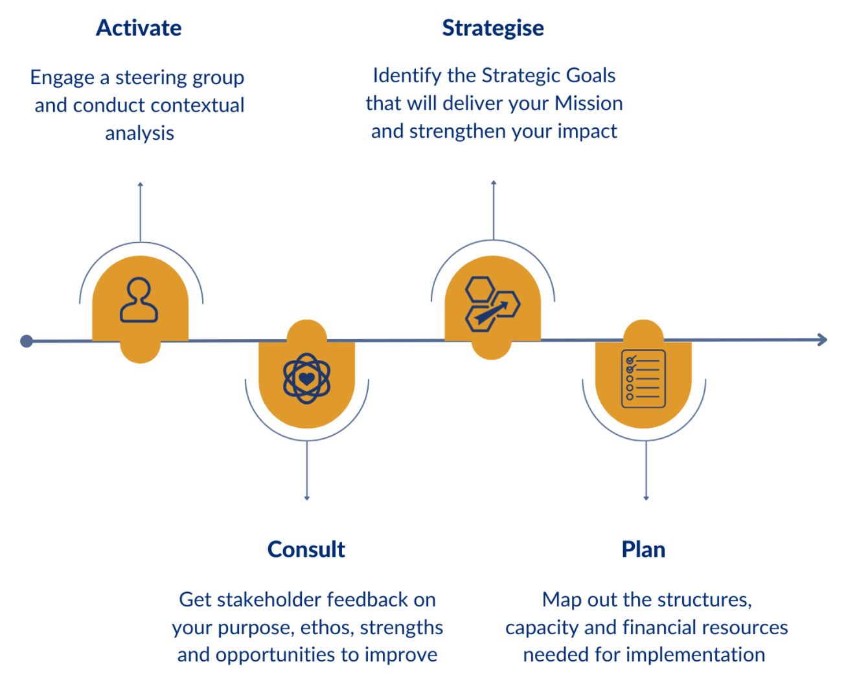
In order to ensure St Catherine’s Strategic Plan was evidence-based and responsive to its operating environment, the initial step of the process involved conducting research into the key trends amongst the population in County Carlow, and understanding the social, economic and political developments relevant to the organisation and its service users. An overview of the contextual analysis findings is presented below.
A priority for St Catherine’s was that its strategic planning process was consultative and participatory, drawing insights from all stakeholders. This approach facilitated the inclusion of diverse perspectives, reflecting St Catherine’s community-based ethos and fostering a shared sense of ownership among all participants. In total, 67 people were consulted with throughout the focus groups, and their valuable feedback shaped the Strategic Plan.
To gather insights on the present and future needs of the individuals, groups, and communities St Catherine’s works with, consultation with those engaged in services was a fundamental aspect of the process. Over a two-day period in early December 2023, focus groups were facilitated with service users of different programmes, soliciting feedback in relation to the strengths and the aspects that people most appreciated about St Catherine’s, as well as on any opportunities for improvement or unmet needs.
Focus groups were also conducted with staff, managers and co-ordinators from across the different programmes to hear their perspectives on strengths and areas for improvement, and to gain insights into the overall staff experience. Recognising the significant contribution of volunteers to the functioning of St Catherine’s, a separate focus group engaged volunteers. These discussions added significant value to the process, providing insights to the wider context the organisation is working in, to the changing needs of service users, and to the specific structures, systems, and processes of St Catherine’s and how these could be strengthened under the new Strategic Plan.
Addressing marginalisation and social exclusion in Carlow and working towards positive outcomes for individuals, families and communities is an aim shared by a range of actors. Therefore, a key part of the process was consulting with relevant partners and funders to gather their input and ensure the Strategic Plan was consistent with and complementary of the direction and aspirations of other actors in the space. In total, nine external partners and funders were individually consulted, including Carlow Regional Youth Services Ltd, HSE Older Person’s Service, Barnardos, Carlow County Development Partnership, TUSLA, HSE South East Community Healthcare, Kilkenny and Carlow Education and Training Board, Carlow County Council, Carlow County Childcare Committee CLG.
At a workshop in January 2024, the Board and CEO reviewed the consultation findings, and began to identify St Catherine’s strategic priorities for the coming years. St Catherine’s Vision, Mission and Values were also considered at this meeting to ensure they accurately reflected St Catherine’s and encompassed the work of the organisation.
The active engagement from a broad spectrum of people throughout the consultations reflected the commitment of different stakeholders to St Catherine’s and was a testament to the inclusive and collaborative ethos that underpins the organisation. An overview of the feedback from all stakeholder groups is outlined below.
In the final stages of the process, the Board considered the organisational structure and capacity that would enable successful delivery of the Strategic Plan. A set of high-level strategic measures of success were identified, as well as a roadmap of priorities for year one.
The final Strategic Plan was presented to the Board and approved on the 5^{th of} June 2024.

Contextual Analysis
Since the establishment of St Catherine’s in 1975, County Carlow has experienced significant change, and a key starting point of this process was a review of the evolving operating landscape in order to identify the current and emerging trends that would impact the organisation and the people it serves. This ensured that the subsequent consultations were situated within the changing landscape of Carlow and beyond, and that ultimately the resultant Strategic Plan responded to external challenges and opportunities. This research was informed by relevant local, national, and regional strategies and plans, socio-economic indicators, relevant studies, and research.
One of the most prominent trends that emerged was the growing population in County Carlow. The proximity of Carlow to Dublin and the strategic inter-county and regional role of Carlow town - combined with emphasis on economic growth and urban regeneration at County Council and regional level - are contributing factors to this growth, which is largely concentrated in urban areas and is projected to continue increasing.
This growing population is significant for organisations such as St Catherine’s as it indicates the potential for increased demand for services. One area associated with this is the demand for community childcare, one of St Catherine’s core services. Despite the increasing population in Ireland, the childcare sector has not expanded proportionately. Rather, recent closures have intensified pressure on existing facilities, signalling a pressing need for proactive planning to cater to the growing number of families seeking childcare services now and in the coming years.
In addition to these population trends, international events have resulted in rapid and at times unpredictable inward migration. New arrivals, particularly those who have migrated due to adverse circumstances, have multi-faceted and complex needs in relation to social inclusion, such as language supports, childcare and employment. St Catherine’s has a long history of successfully supporting the integration, inclusion, and well-being of new communities. These shifts in demographics mean that St Catherine’s and other organisations working in the community development space are considering their role in fostering a multicultural and inclusive environment, looking at how they can adapt and accommodate new needs while remaining responsive to existing populations.
Although deprivation in Carlow falls marginally below the national average, and overall levels of deprivation are declining nationwide, trends indicate that the most deprived communities in Ireland are experiencing the least improvements and are falling further behind. The widening gap between the least and the most affluent in society is of considerable concern, resulting in pockets of society that are increasingly vulnerable to protracted social exclusion and marginalisation. This trend prompted St. Catherine’s to contemplate the future implications in terms of its target demographics and outreach efforts.
Since St Catherine’s works across the life cycle and engages with various groups in society, the contextual analysis focused on evaluating trends relevant to the demographics and communities St Catherine’s works with. Overall, it was clear that in many instances there is consistent or increasing socio-economic vulnerability of several cohorts, who for different reasons are especially susceptible to marginalisation and deprivation.
One of the groups considered here was lone parents and their children. According to 2022 figures, 44% of one-parent families live in deprivation, 24% are at risk of poverty and 14% live in consistent poverty.
While employment in Carlow has increased, the rates of unemployment are slightly higher than the national average. Nationally, approximately 37% of unemployed persons are at risk of poverty, compared to 6% of those that described themselves as employed.
In relation to older people, the population of over 65s in Carlow continues to grow and has increased by 26% since 2016, slightly ahead of the national average. Nationally, in 2022 the risk of poverty rate was highest amongst single adult households. Alongside this, those who lived alone are at higher risk of loneliness and social exclusion, an issue that was exacerbated by Covid19 and is considered by the World Health Organization as a global public health concern. Older people are also at higher risk of digital exclusion, a particular challenge in an era of rapid digitalisation of public services and social life.
The Traveller Community in Carlow has witnessed a notable 12% growth from 2016 to 2022, and Carlow is bordered by counties with high Traveller populations. This growth occurs against a backdrop of persistent challenges, as the Traveller Community across Ireland experience higher rates of discrimination and exclusion, with poor mental health and suicide identified as critical issues within the community.
Factors contributing to socio-economic disadvantage often intersect and overlap, leading to generational deprivation and cyclical exclusion that can be challenging to address. Looking forward, St Catherine’s wished to continue its valuable, wrap-around supports that are key to enhancing both social and economic prospects, while exploring opportunities to improve and adapt in order to meet evolving and growing needs.
When applying a more internal lens, the current landscape across Ireland presents a challenging one for nonprofits and charities, with the cost-of-living crisis and the housing crisis exacerbating situations of poverty and vulnerability. This in turn places pressure on organisations supporting communities that are most vulnerable to economic changes. In addition, inflation is leading to increased rising costs, and staffing and recruitment persist as considerable challenges.
These trends consolidated the continued and increasing need for the presence of St Catherine’s in Carlow and prompted consideration of how the organisation could be future proofed to strengthen current service delivery while ensuring preparedness and proactiveness for the future.

Consultation Insights
Strengths
The consultations drew from a diversity of perspectives, however consensus emerged around several key strengths, highlighting areas to cultivate and to carry forward into the next Strategic Plan.
All stakeholder groups shared the view of St Catherine’s as a welcoming and inclusive environment, one in which people are treated with respect and kindness and are free to seek support without fear of discrimination or prejudice.
This environment has been created and fostered by a dedicated staff team that demonstrate high standards of professionalism while also being approachable, friendly, and helpful. Staff and volunteers were considered as adding a lot of value to the organisation through their support and commitment. It was also observed that volunteering is a mutually beneficial activity, providing important support to St Catherine’s while also resulting in positive outcomes for volunteers.
The open door, community-based approach is particularly valued by service users, who demonstrated high levels of trust in the organisation and its staff. The commitment to inclusion and non-judgment has enabled St Catherine’s to establish links with groups and communities often considered as “hard to reach” by other agencies. This is a crucial strength, allowing St Catherine’s to support those who typically may not be accessing mainstream services.
A key strength of St Catherine’s is the diversity of its service offering, the existence of a range of complementary supports that are needs-orientated and responsive. These services were perceived as hugely valuable and impactful, offering opportunities for learning and progression, creating pathways into employment and education, and facilitating social engagement and connection. Through these services, people experience numerous enduring benefits, such as enhanced confidence and well-being, skills development, the cultivation of personal interests and hobbies, and the fostering of new friendships within the community. A unique and highly regarded aspect of St Catherine’s are its two community childcare services which support and enable parents to avail of educational programmes.
St Catherine’s plays a key role in the wider ecosystem of community development in Carlow, a landscape which was considered as cohesive and cooperative. Through its consistent collaboration and partnership, St Catherine’s works effectively with other organisations and agencies to seek the best possible outcomes for individuals, families and communities and is active in relevant local and regional discussions and decision-making. Sustaining and building on the collaboration and shared learning at this level was identified as welcome moving forward.
A final strength which emerged throughout the consultations was St Catherine’s commitment to high standards of governance and compliance. This commitment underscores the organisation's dedication to operating ethically, transparently, and in accordance with established regulations and best practices.
The Strategic Plan reflects and incorporates the strengths that were identified by St Catherine’s stakeholders, ensuring that these are retained and remain priorities in the coming years.

Areas for Improvement
The consultations also identified areas in which St Catherine’s could perhaps be stronger, or where it could adapt its approach. These areas for improvement were valuable in terms of shaping opportunities to explore under the Strategic Plan.
The first of these is the challenge associated with the continuous gradual expansion St Catherine’s has experienced since its inception, and with being an organisation that is responsive to changing needs in the community. While the diversity of the service offering at St Catherine’s was considered as valued by many, it poses challenges in that the remit of the organisation is quite broad. On a similar thread, some stakeholders – including some services users, volunteers and funders - are not fully aware of the range of services offered by St Catherine’s, and in turn the full extent of its impact in the community.
This provoked deliberation as to how the Strategic Plan could assist in defining and framing the services, and prompted the organisation to also consider how communications could be strengthened to consolidate the role of St Catherine’s and the impact it has.
The changing landscape means that St Catherine’s is supporting more people and is constantly adapting to accommodate new needs. This includes additional complex needs being presented amongst children involved in St Catherine’s community childcare services. This highlighted a need for additional capacity in particular areas, as well as improvements in the efficiency of operations and working systems. Addressing the challenge of limited space emerged as an area requiring increased focus, and suggestions emerged around potential opportunities to use alternative spaces to deliver services. At the time of delivering the Strategic Plan, the building of the new extension was already in progress.
It became evident that any further growth must be sustainable and consistent with organisational capacity. To ensure St. Catherine’s is well-positioned to achieve the Strategic Plan’s Goals and effectively serve the community, the Organisational Effectiveness pillar of the Strategic Plan focuses on practical steps to consolidate the recent growth and planned extension. This includes actions to enhance impact, support staff and volunteers, and utilise space efficiently.
In terms of St Catherine’s community educational programmes, services users noted that the eligibility criteria had historically been quite restrictive, thus limiting the participation of certain groups. Moving forward, with a change in funding arrangements for some of the programmes, St Catherine’s will be able to remove those barriers and facilitate the inclusion of more groups. Likewise in terms of reach and inclusion, it was identified that increasing outreach would strengthen St Catherine’s impact across demographics and locations. A number of specific service user needs were identified throughout the consultations, for example the provision of digital literacy skills and informal English language supports for new communities. The Strategic Plan outlines St Catherine’s approach in responding to these needs.
Ensuring there is continued investment in programmes underpins all of the above and is crucial to ensure St Catherine’s can continue to meet current and emerging needs and develop their existing programmes. Continuation of current funding and accessing new funding streams were considered as vital and this is reflected across different pillars of the Strategic plan.
While challenges emerged over the course of the consultations, each one reflected an opportunity for progression, and was met with an appetite for positive change. The areas mentioned above have been incorporated into the Strategic Plan, reflecting St Catherine’s desire for continuous improvement and openness to positive change.

Strategic Goals
St Catherine’s vision is of a just and inclusive Carlow where all individuals and families are empowered to enhance their lives and communities
Mission
Vision
Pillars
Capacity-building
Values
- Build the capacity of individuals and communities in Carlow to self-determine their future

- Continue to develop and widen access to our community education programmes

- Expand our provision of wellbeing & counselling supports
St Catherine’s mission is to provide responsive, wrap-around services to the community that build people’s capacity and promote their social inclusion

St Catherine’s Community Services Centre: Strategic Plan 2024-2028 at a glance
Welcoming - Empowerment - Equality - Non-judgment - Diversity & Inclusion
Who we work with
Social inclusion
- Contribute to social inclusion in Carlow

- Deliver tailored supports to enable the social inclusion of new communities

- Consolidate our supports to the Traveller community across Carlow

- Contribute to the social inclusion of older people
Childcare & family support
- Ensure our Community Childcare service has the capacity to meet the needs of those in our care

- Strengthen and expand our family and parental supports
Organisational effectiveness
- Effectively communicate our work and its impact

- Continue to invest in and value our staff and volunteers

- Ensure we have appropriate spaces out of which to reach and serve the community

- Foster effective community relationships across Carlow
Families
Young mothers & their children
Lone parents & their children
The Traveller Community
New communities
Older people
People at risk of disadvantage

St Catherine’s Vision, Mission and Values

Vision
St Catherine’s vision is of a just and inclusive Carlow where all individuals and families are empowered to enhance their lives and communities
Our Vision sets out our aspirations for Carlow and what we are working towards as an organisation

Mission
St Catherine’s mission is to provide responsive, wrap-around services to the community that build people’s capacity and promote their social inclusion
Our Mission encompasses our purpose, and how we work to achieve our Vision

Values
Welcoming
Empowerment
Equality
Non-judgment
Diversity & Inclusion

St Catherine’s Strategic Plan 2024-2028
Strategic Goals and Actions

CAPACITY-BUILDING
1. Build the capacity of individuals and communities in Carlow to self-determine their future
- Secure funding for Community Development workers to enable outreach to communities across geographies and demographics
- Continue to support the Carlow Traveller Forum

2. Continue to develop and widen access to our community education programmes
- Secure continued funding and widen eligibility criteria and access where possible for The Moving On Programme, Learning For Everyday Life & Preparation for Work
- Continue to access funding for informal community education opportunities that meet evolving needs
- Secure funding to continue offering opportunities to develop digital literacy

3. Expand our provision of wellbeing & counselling supports
- Develop our County-wide social prescribing service
- Secure funding to expand counselling supports
- Develop our Traveller wellbeing supports given extra team capacity

SOCIAL INCLUSION
4. Contribute to social inclusion in Carlow
- Continue to remain responsive to people's social inclusion needs
- Continue to meet the evolving social inclusion needs of parents and children
5. Deliver tailored supports to enable the social inclusion of new communities
- Support informal English language and literacy for practical day-to-day living, especially for the most marginalised
- Remain responsive to the social inclusion needs of new communities
6. Consolidate our supports to the Traveller community across Carlow
- Continue to develop county-wide outreach services
7. Contribute to the social inclusion of older people
- Trial new opportunities for enhancing the social inclusion and connection of older people
- Promote volunteering opportunities for older people within St Catherines
- Continue to develop the Meals on Wheels service in response to needs

CHILDCARE AND FAMILY SUPPORT
8. Ensure our Community Childcare service has the capacity to meet the needs of those in our care
    - Secure funding to increase number of staff and to reduce child-staff ratios
    - Explore opportunities to improve efficiency of IT and admin systems
    - Advocate for the provision of state services for those with additional needs
9. Strengthen and expand our family and parental supports
- Continue to deliver universal and targeted group programmes for families when possible
- Expand our Teen Parent Support Programme to include young parents up to 24 years of age
- As opportunities arise, expand our provision of family supports including therapeutic services across Carlow town

ORGANISATIONAL EFFECTIVENESS
10. Effectively communicate our work and its impact
- Maintain practice of robust impact monitoring across the organisation
- Seek to capture and communicate overall organisational impact
- Develop our external communications (website, social media, local media)
- Communicate the value of our work to our funders
11. Continue to invest in and value our staff and volunteers
- Further develop our internal communications and team building
- Engage in regular reviews of our staffing structure & capacity to ensure it remains fit-for-purpose
- Continue to provide training & development opportunities for staff to ensure our work remains aligned to best practice
- Progress our volunteer induction & coordination practices
- Support the smooth succession, recruitment & induction of new Board members, and maintain the balance of skills, expertise and experience on the Board
12. Ensure we have appropriate spaces out of which to reach and serve the community
- Deliver the extension to the St Catherine’s premises
- Continue to collaborate with other community organisations to deliver services in other premises if and when required
13. Foster effective community relationships across Carlow
- Continue to listen to the local community to remain responsive to emerging needs that fit our mission
- Continue to collaborate and engage closely with partners and funders to ensure our work complements each other's

We will know if we have delivered this Strategic Plan if

- Our service users tell us that our services are having a positive impact on their lives
- We can demonstrate that we have taken on new, or adapted existing, programmes based on emerging needs in our community
- We engage, support and include new services users with our services
- We have positively influenced the case for additional targeted resources to support children with additional needs in Community Childcare services
- Our staff and volunteers tell us that they feel valued as part of St Catherine’s
- We comply with good governance practice including around Board succession and recruitment
- We can demonstrate that we live our Values through our services

Survey on Income and Living Conditions, SILC (2022) https://www.cso.ie/en/releasesandpublications/ep/psilc/surveyonincomeandlivingconditionssilc2022/poverty/
ibid
WHO declares loneliness a ‘global public health concern’, The Guardian, (16.11.2023) https://www.theguardian.com/global-development/2023/nov/16/who-declares-loneliness-a-global-public-health-concern
CSO 2022

